from WWatching Website

The story of the development of navigation and map making as it is commonly understood goes something like this.

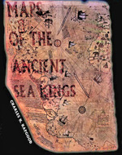
The earliest maps that we know of were made on clay tablets and come from the ancient Babylonians around 2300 BC. These maps were of land lots and were used to control taxation. There are maps made on silk from China around the 2nd century BC. The Mayans andIncas made maps of the territories they conquered. In the early 1300's navigators developed maps of the Mediterranean and other known coastlines. Finally in modern times we have perfected the art of map making and navigation.
"Only since the late 1700's has it been possible to collect & record truly accurate geographic information"
[Encarta Encyclopedia : Geography & Maps, History of]
The following maps are very much ancient enigmas because they simply do not fit in our current model of history.
- The Piri Re'is Map of 1513
- The Maps of Antarctica
- Excerpts from "Maps of the Ancient Sea Kings"
Return

Piri Re'is Map of 1513
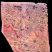
There is a map, dating from 1513, which was made by a man named Piri Ibn Haji Memmed, otherwise known as Piri Re'is. This man was an Admiral in the Turkish navy. Today we only have a fragment of the original map. (click image right)
Piri Re'is made a number of very interesting claims about this map:
- He claimed it was made from approximately 20 original source maps
- He claimed the western portion of the map was obtained from Christopher Columbus
- He claimed some of the source maps were dated from the time of Alexander the Great
- He claimed some of the maps were based upon mathematics
These are pretty amazing claims. An initial examination of this map seems to support the idea that the western portion (the map of the coastline of the Americas) was done by people with little or no knowledge of what the coastline actually looked like. The reason for this conclusion is the coastline of the America's looks very distorted.
This map was drawn using the Equidistant projection method. Also, instead of using the standard markings of latitude and longitude that are common on today's maps. Instead maps of the "portolan" style were drawn using a series of points from which a series of lines radiate outward. One such mechanism for drawing these maps was the "Eight Wind" system. Others including the Sixteen Wind system etc. also were used.
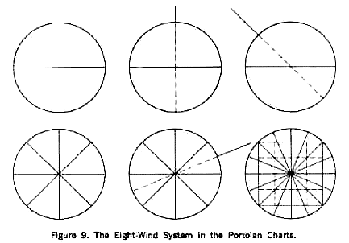
The reasons for such drawing methods have long been assumed to benefit the mariner. This is because these lines seem to correspond to the points of the compass, which also began to surface in Europe around the same time. This method of drawing would also greatly benefit the map map maker as well.
It is interesting to note that the portolan maps that surfaced in the AD 1300's did so without any evidence of development. Also throughout the next several hundred years they did not show development either. From fourteenth through the sixteenth century AD there is no material modifications to these maps. Further they are all drawn from the same scale. This suggests that the maps were not being developed as a result of mariner survey activity. Also the lack of variance in scale may suggest that the understanding of these maps, and the mathematical principles behind them, was not understood.
Charles Hapgood performed a detailed analysis of this map. He worked with students from Keene State College, as well as with cartographers from the US Air Force. After a detailed analysis, several interesting observations were made.
- The map appears is composed of at least six separate source maps.
- The map provided remarkably accurate latitude and longitude locations of coastal features of Africa, North and South America, and a portion of Antarctica. (This point is contested by many people and is addressed later in the section on Antarctica).
- The source maps themselves utilize the principles of plane geometry and an ability to account for the curvature of the earths surface.
- The knowledge of longitude suggests either a people, or a mechanism, that are currently unknown to us. (This is because the ability to determine longitude with any degree of accuracy is not known before AD 1700 (?) ).
- The map is based on an equidistant projection with its center on the meridian of Alexandria in Egypt.
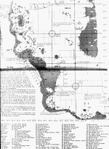
Mr. Hapgood presented a number of exhibits in his book, The Maps of the Ancient Sea Kings to support these claims. He also presented a plethora of empirical evidence to back up these points. Click image left to see a large map from that book indicating the location six maps, the features that have been verified with modern geography, etc. Although the accurate mapping of the coastline of the Americas is amazing examine the portion of Antarctica that is also illustrated.

NOTE: There is significant debate about whether or not this is actually Antarctica. Mr. Hapgood himself comments that if this was the only evidence we had that the ancients had mapped Antarctica it would be questionable. Examine the later section on Antarctica for much more credible maps of it.
To understand the method of projection examine the following map. This is a section of an equidistant projection centered on Memphis Egypt. This map was produced by the US Air Force. Note the similar distortion of the coastline of the Americas between Piri and this map.
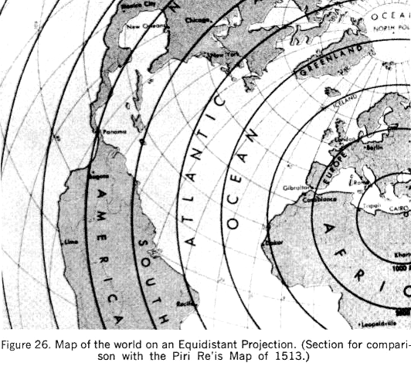
This map shows the super-imposition of the portolan type projection on the equidistant projection. Note that the numbers on the outside of the largest circle correspond with projection points on the map of Piri Re'is.
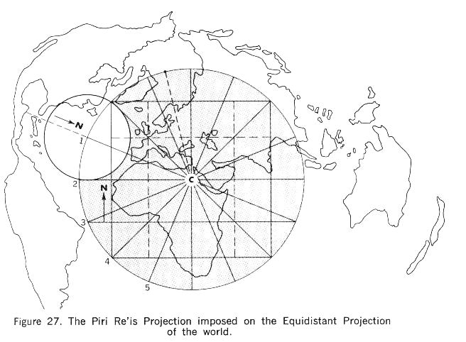
The degree of accuracy contained in the Piri Re'is map is extraordinary. Given that the author of this map himself claimed to have based this map, not on his own surveying skills, but rather on ancient maps going back to the 1400's and earlier, serious questions about the development of navigation as we currently understand it.
Go Back

The Maps of Antarctica
Officially Antarctica was discovered in the early 1800's. Its existence is said to have been theorized by the ancient Greeks who realizing the amount of land in the northern hemisphere assumed that this mass must be balanced by a proportionate mass in the southern hemisphere.
Also, the continent of Antarctica, according to modern science, has been covered with ice for millions (sic) of years. This would make it impossible for anyone, especially the ancients to actually map its coastline.
Unfortunately for some there are maps, dating from at least the early 1500's that not only indicate the existence of Antarctica, but also map its coastline in amazing detail.
One such map is the Oronteus Finaeus World Map of 1532. The section of this map indicting Antarctica is shown below (click image to enlarge). Keep in mind that this projection method is different than those that you are used to seeing today.
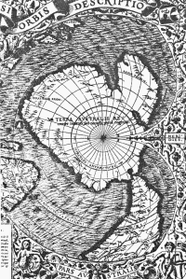
Charles Hapgood and his team converted this map from its current projection method into a modern projection method. Look at the results.
Click images to enlarge
This first image is simply the map as it was drawn by Oronteus Finaeus  . | Next they converted it to a modern projection method as shown here  . | Compare the left image with a modern map of Antarctica to see at a glance just how close they were
Well if the existence was only theorized, the people developing these theories were also able to theorize the coastal features of this theoretical continent.
The problems posed by these maps of Antarctica are not trivial.
- First of all it demonstrates that sometime in the history of the earth, before at least the 1500's a sea faring people existed that could circumnavigate the globe and accurately survey its features.
- Second it raises the question of, if the ice cap has been in place for millions years how was this accomplished?
- Did the maps originate prior to this time?
- Was it mapped while the ice caps were in place?
- Is the ice cap development actually a much more recent event than we think?
There are several other maps of Antarctica that could be presented here. These are covered in Mr. Charles Hapgood's book Maps of the Ancient Sea Kings (see excerpts HERE).

